UCS1712

**Graphics and Multimedia Lab**

**Mini Project**

**Group Members**

P T Jayannthan – 205001049

Koushik Viswanath S - 205001055

Graphics and Multimedia LAB

Mini Project Report

🦇 The Batman 🦇

**Aim:**

To render a 2D model and animation of a Batman Sequence to explore various graphics and multimedia tools of Blender.

**Tools:**

Blender - version 3.6

**Implementation:**

1. **Creation of 2D Batman Model:**

A detailed 2D representation of Batman was crafted within Blender by tracing the character's outline, ensuring a faithful portrayal.

1. **Filling the Silhouette:**

After establishing the outline, the interior of the Batman silhouette was completely filled with a black color.

1. **Isolating and Emphasizing the Eyes:**

A distinctive touch was introduced by isolating the eyes and preserving them from the black fill. This particular emphasis on the eyes was carefully maintained at specific keyframes, enhancing the character's expressiveness and preserving Batman's recognizable look.

1. **Keyframe Animation:**

Dynamic movement was infused into the animation through the strategic placement of keyframes. Altering the shape of the Batman model at different keyframes resulted in a fluid animation sequence. This technique facilitated seamless transitions between various poses, breathing life into the character.

1. **Transformations in Keyframes:**

Each keyframe represented a pivotal moment in the animation timeline. Transformations applied to the Batman model in these keyframes encompassed changes in position, scale, and shape.

1. **Integration of Audio:**

An additional layer of richness was introduced to the animation sequence by incorporating audio elements. The synchronization of sound with the visual elements enhanced the overall immersive experience, contributing to a more captivating portrayal of the Batman sequence.

**Screenshots of the Demo:**

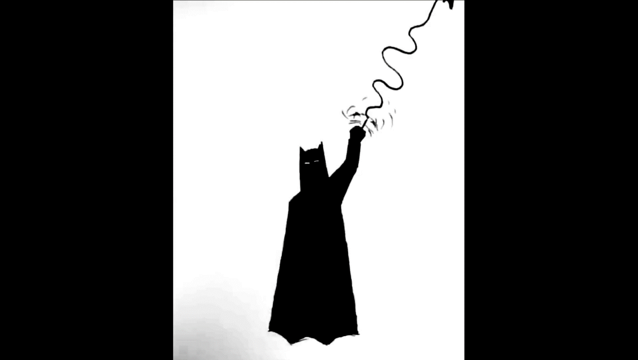 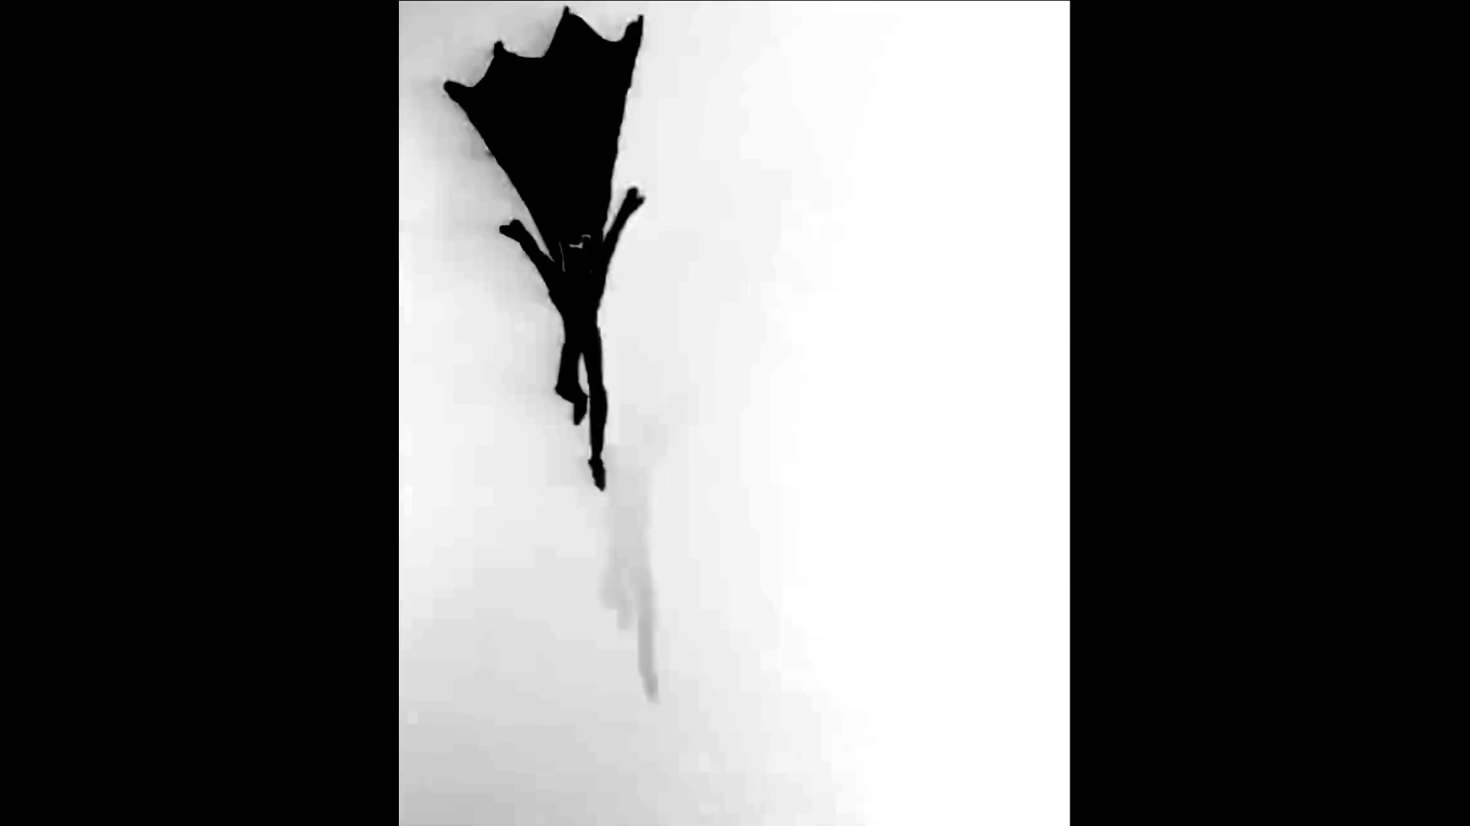

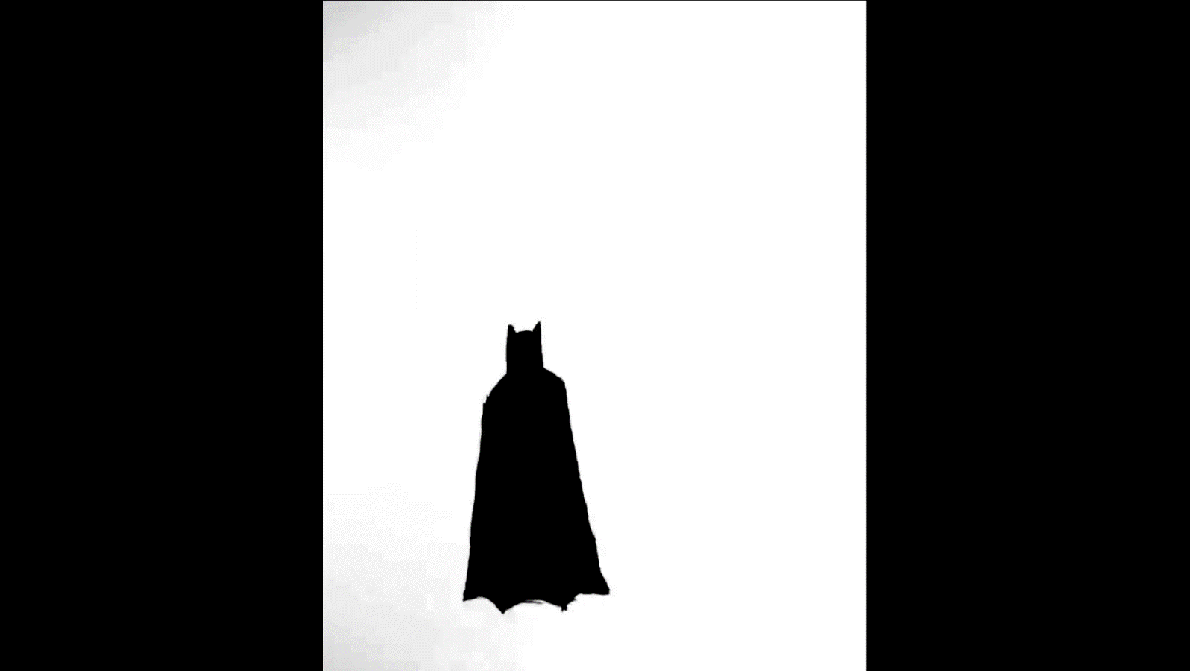 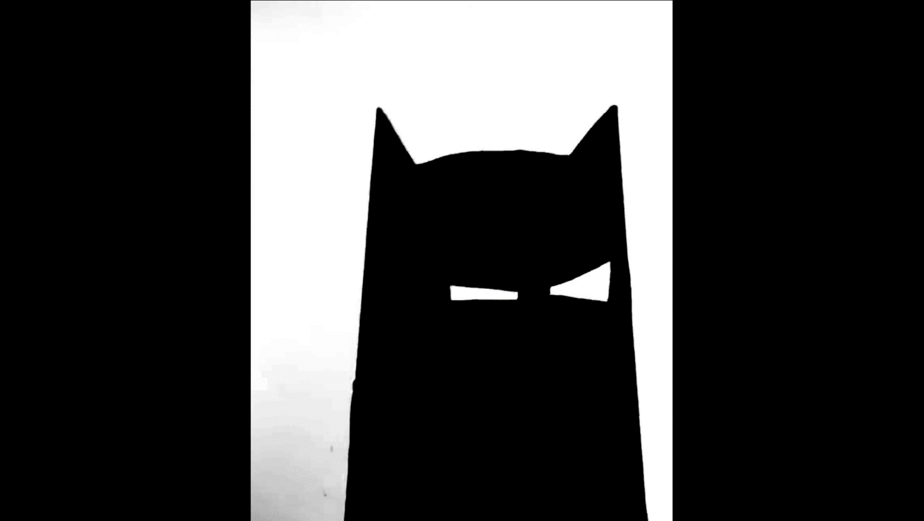

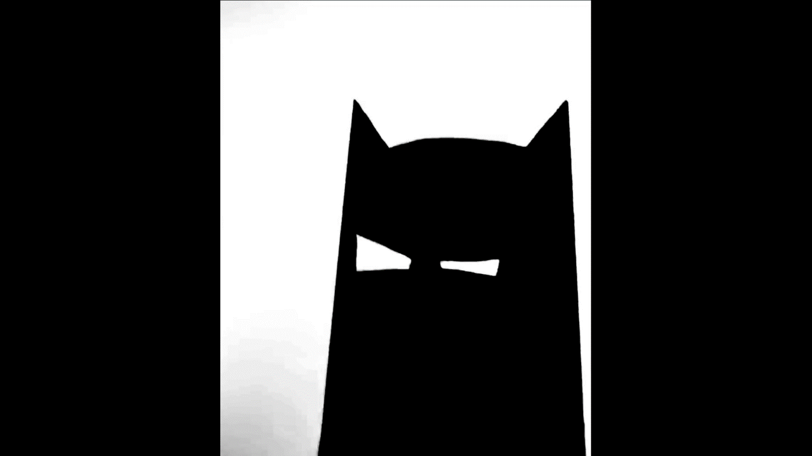 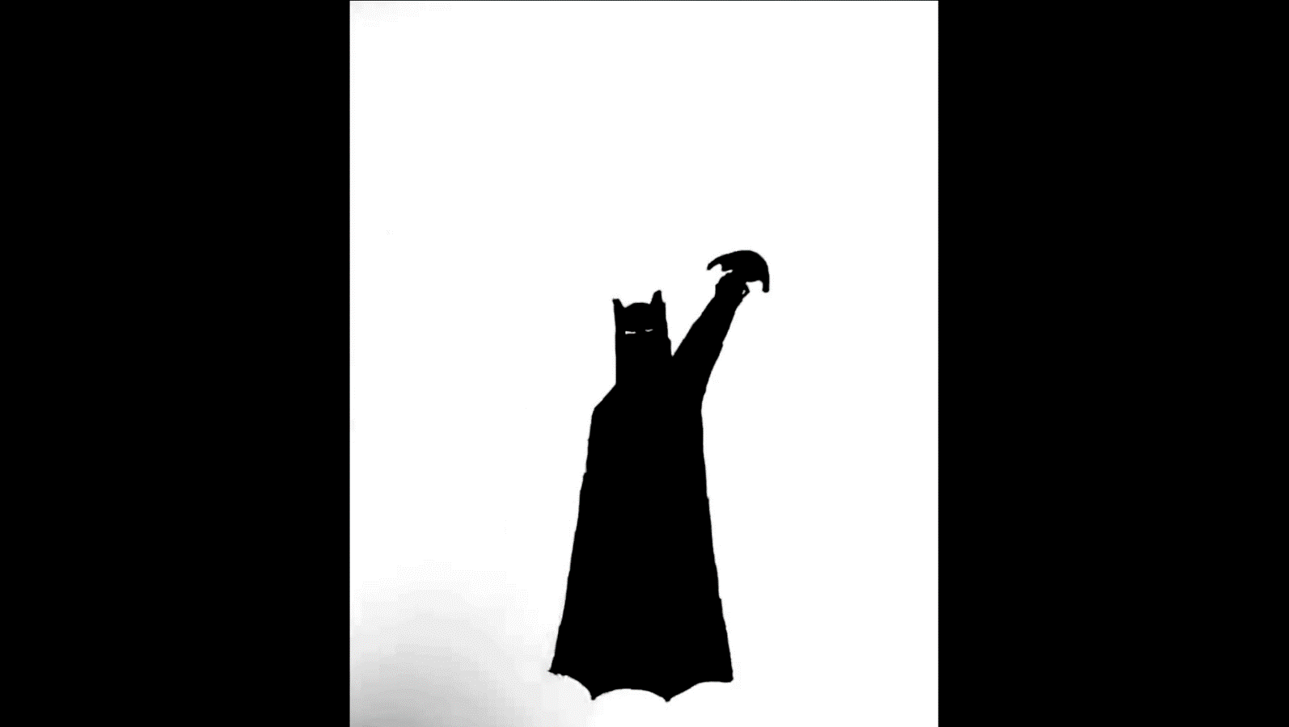

**Result:**

The 2D animation depicting the Batman sequence has been successfully created and rendered.